1.Download latest eclipse.

2.Click on File->New->JPA Project

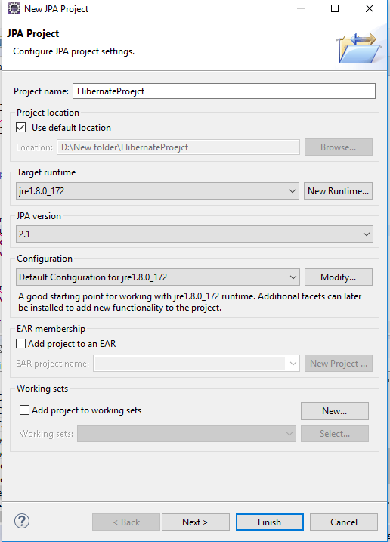

3. Click on Next->Next

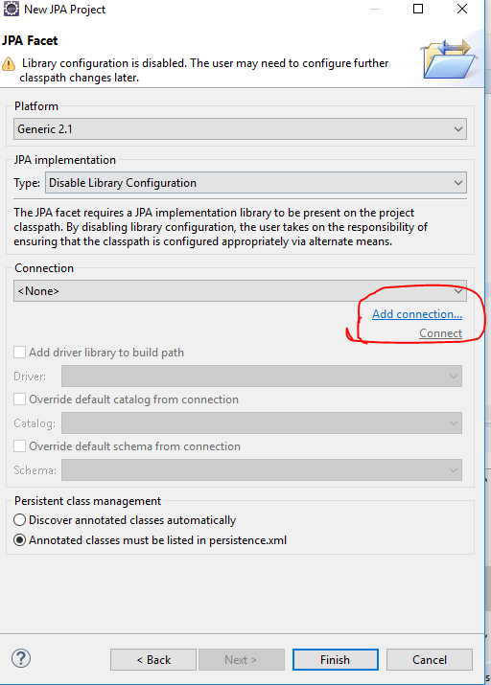

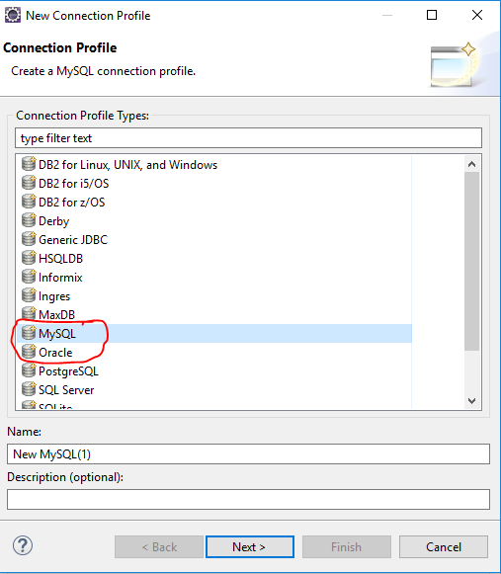

Click on Next

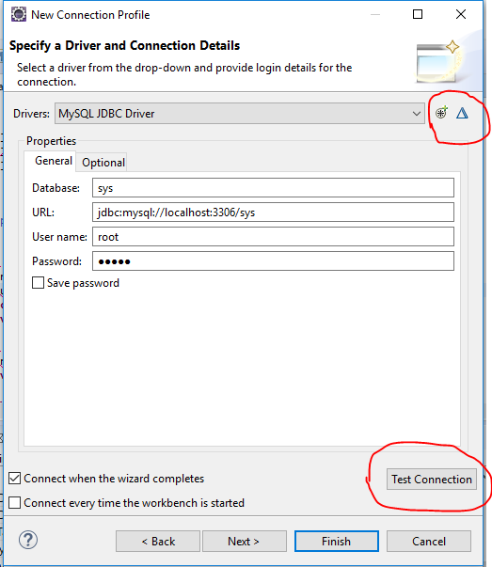



For adding/Editing new properties and JARS.

Test the Connection and click finish.

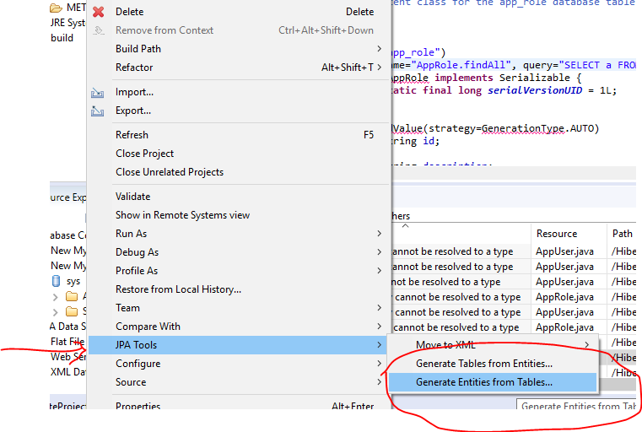

Right Click on project and Go to JPA tools for Generate Entities from Table.

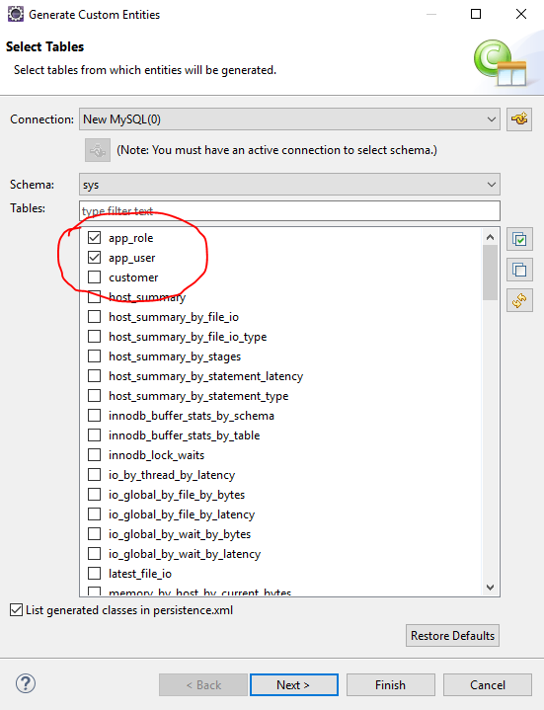

Choose the table you want to create entity and click next.

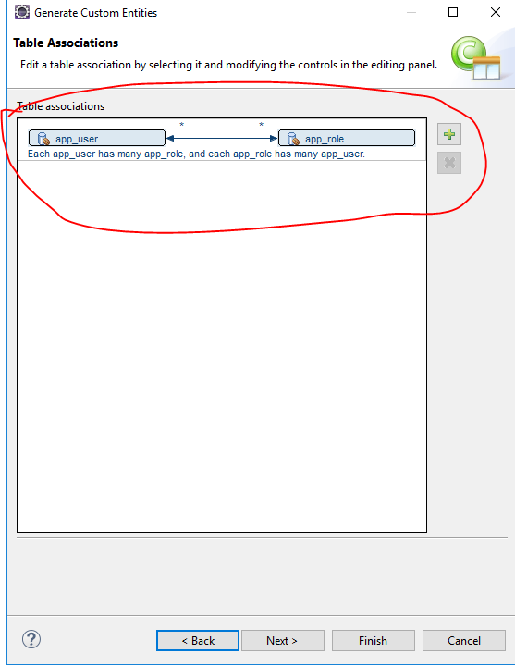

Click next and choose the entity settings ,then click finish.